

ST10437112 NTSAKO LUBISI-WEDE-POE

ROSEBANK COLLEGE NELSPRUIT



Table of Contents

NP BOUTIQUE 1

HOMEPAGE 1

ABOUT US 1

Mission 2

ST10437112 NTSAKO LUBISI-WEDE-POE

ROSEBANK COLLEGE NELSPRUIT

Vision 2

Target audience 2

Contact Us 2

Objectives and goals of having a website 2

KEY PERFORMANCE INDICATORS 2

BUDGET 2

CONCLUSION 3

# **NP BOUTIQUE**

I have created a website for a small business called NP Boutique which was established in 2024. The business focuses on affordable, high quality trendy clothes for women and men. The website will allow the business to grow and gain popularity, which will help grow the number of customers. NP Boutique started with just selling few products, now they sell more than 30 items per day and they aim to have a growing online presence in other countries.

# **HOMEPAGE**

On the website homepage there are high quality visually appealing images, showcasing what the business is about. There is also a search bar that will help customers discover products they are looking for easily such as sales, new arrival, cart. The homepage also has a shop page which categories the clothes into women and men section.

(Anon., 2020)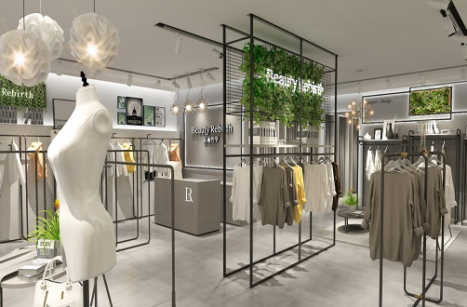

The Homepage also has a business logo

(Anon., 2010)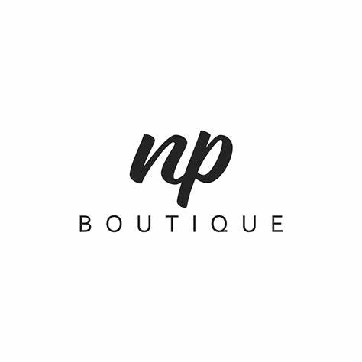

The logo consists of letters “NP” which stands for Ntsako Praiseweath which is the owner or founder of the business. The logo is black with a white background which represents professionalism and sophistication, it also represents exclusivity meaning customers can express themselves through fashion and they play a role in completing their own style journey. The logo also represents beauty and elegancy. Lastly the theme (black and white) represents simplicity and class.

Homepage has a subscription newsletter where customers get 15% off their first order or purchase when they signup using their email to receive latest fashion trends the business has to offer.

# **ABOUT US**

NP Boutique is a clothing brand, that was established to give customers the opportunity to define themselves using fashion. The boutique offers elegant clothing for men and women aged 20-40, making sure they look and feel their best.

(Sayler, 2020)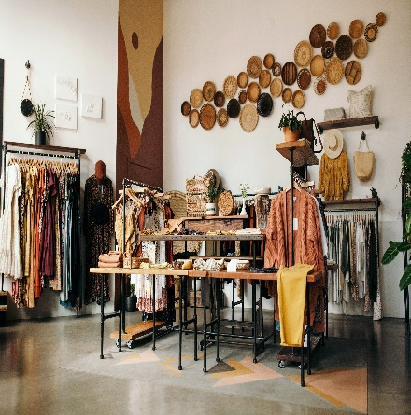

## Mission

To provide elegant high-quality fashion.

## Vision

To become one of the most leading fashion boutiques.

## Target audience

Men and women aged 20-40 who are obsessed with fashion and looking good.

# **Contact Us**

If customers need any advice regarding our services or products or they have questions, they should feel free to contact us or visit our store:

Location: 41 Brown Street, Nelspruit, 1200

Mobile number 🕿: 0711574386

Email 🖂: [Npboutique@outlook.com](mailto:Npboutique@outlook.com)

Social media: NP Boutique

Business Hours: Monday- Friday (9am-6pm)

# **Objectives and goals of having a website**

The competitive environment is fierce right now. Having a website is really important, it will help my small business raise its brand awareness, cultivate relationships with customers, enhancing sales and fostering loyalty. The website will also help in showcasing the boutique products where customers will see what they are buying and how much the product cost. Lastly the website will help in creating brand visibility. (Nicol, 2023)

# **KEY PERFORMANCE INDICATORS**

This will help in measuring the business success or progress such as profit, customer retention rate, time it takes the business to deliver products, website traffic lastly how fast the products sell and what improvement the business has to work on. (Twin, 2025)

# **BUDGET**

The estimated budget is R2 000 per year.

|  |  |
| --- | --- |
| Type |  |
| Once off setup | R700 |
| Annual | R900 |
| Monthly | R300 |

# **CONCLUSION**

The success of the website will increase the business sales, grow the brand lastly it will help in improving customer’s engagement. The business aim to create an elegant shopping experience for their customers.

# References

Anon., 2010. *Alamy.* [Online]   
Available at: https://www.alarmy.com/np-beauty-vector-initial-logo-art-handwriting-logo-of-initial-signature-wedding-fashion-jewellery-boutique-floral-and-botanical-with-creative-temp-image.html  
[Accessed 4 April 2025].

Anon., 2020. *Fashion Boutique Store Design.* [Online]   
Available at: https://boutiquestoredesign.com/design/womens-fashion-garmrnt-clothing-store-layout-plan-design  
[Accessed 5 April 2025].

Nicol, S., 2023. *Essential objectives of a website.* [Online]   
Available at: https://www.chillybin.co/importance-defining-goals-creating-website/  
[Accessed 2 April 2025].

Sayler, N. M. a. Z., 2020. *SeattleMet.* [Online]   
Available at: https://www.seattlemet.com/style-and-shopping/2020/09/best-clothing-stores-and-boutiques-in-seattle  
[Accessed 4 April 2025].

Twin, A., 2025. *KPIs: What Are Key Performance Indicators? Types and Examples.* [Online]   
Available at: https://www.investopedia.com/terms/k/kpi.asp  
[Accessed 2 April 2025].